Teacher  Tiffany White |  |  | Date  4/7/14 |  | Grade  9/10/11 |  | Content Area  Social Studies
Objective/Essential Question:  Study a historical narrative.  What happened to the Titanic?  Why do we talk about the Titanic?  - Physical Skills: Interact with smart board and classroom technology.  - Cognitive Skills: Answer comprehension questions.  - Social Skills (learning teams): Work in teams. Turn taking |  |  |  |  |  |  |  |  | Plan for Differentiation:  Using Bloom’s Revised Taxonomy  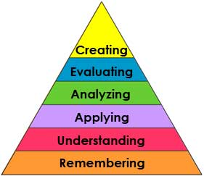
Curriculum Standard  Students use a variety of technology to answer questions. |  | Technology  Smartboard, IPADs |  |  |  |  |  |  | 21st Century Skills  How did the Titanic affect modern ships? How did Titanic change the way people travel on the ocean?
Materials  Smartboard, Smart Notebook, Map |  | Vocabulary (Literacy)  Titanic  Ship  Sink  Iceburg
Lesson Procedures
Review(Links to Prior Knowledge, Anticipatory Set):

We use many ways to travel. What are some types of transportation? (Students point to pictures on chart) A ship is a form of transportation.
What the teacher will do:

Review smart lesson, show vocabulary cards, use visuals related to transportation and Titanic, ask comprehension questions.

What the teacher assistants will do: Take data and assist students in choice making
Guided/Independent Practice
Follow smart lesson, interact with lesson on smart board
Assessment/Check for Understanding
Students will answer comprehension questions: What was the Titanic? What happened to the Titanic?....
Students will say whether they liked the lesson or not

Closure/Summary
Students give their opinion of the reading

Reflection  (after teaching the lesson) | Differentiation |  |  | Student Engagement |  | Data  Collection |  | Higher Level Question |  | Lesson Effectiveness
 | Low High  1 2 3 4 5 |  |  | Low High  1 2 3 4 5 |  | Low High  1 2 3 4 5 |  | Low High  1 2 3 4 5 |  | Low High  1 2 3 4 5
Comments | What would you do differently and what worked well?

