Teacher  Amber Askew/Tiffany White |  |  | Date  5/12/14 |  | Grade  9/10/11 |  | Content Area  Social Studies
Objective/Essential Question:  What is a national anthem? What is the American national anthem?  - Physical Skills: Interact with smart board and classroom technology.  - Cognitive Skills: Answer comprehension questions.  - Social Skills (learning teams): Work in teams. Turn taking |  |  |  |  |  |  |  |  | Plan for Differentiation:  Using Bloom’s Revised Taxonomy  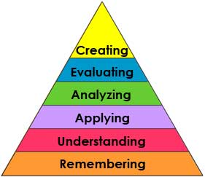
Curriculum Standard  Students use multiple sources of information to utilize tools to understand historical facts. |  | Technology  Smartboard, IPADs |  |  |  |  |  |  | 21st Century Skills  Students will interact with the technology, making choices, and use critical thinking skills.
Materials  Smartboard, Smart Notebook, Vocabulary cards |  | Vocabulary (Literacy)  National Anthem  Patriotic  Song
Lesson Procedures
Review(Links to Prior Knowledge, Anticipatory Set):

Review lesson on American inventions.
What is a national anthem? The national anthem is a song that represents loyalty to one’s country. In America, our national anthem is called “The Star-Spangled Banner”
What the teacher will do:

Review smart lesson, show vocabulary cards, use visuals related to national anthem, and ask comprehension questions.

What the teacher assistants will do: Take data and assist students in choice making
Guided/Independent Practice
Follow smart lesson, interact with lesson on smart board
Assessment/Check for Understanding
Students will answer comprehension questions: What is a national anthem? What is America’s national anthem? Are there any other songs about America?
Students will say whether they liked the lesson or not.

Closure/Summary
Listen to national anthem and other patriotic songs.
Students give their opinion of the lesson.

Reflection  (after teaching the lesson) | Differentiation |  |  | Student Engagement |  | Data  Collection |  | Higher Level Question |  | Lesson Effectiveness
 | Low High  1 2 3 4 5 |  |  | Low High  1 2 3 4 5 |  | Low High  1 2 3 4 5 |  | Low High  1 2 3 4 5 |  | Low High  1 2 3 4 5
Comments | What would you do differently and what worked well?

