Teacher  Amber Askew/Tiffany White |  |  | Date  5/27/14 |  | Grade  9/10/11 |  | Content Area  Social Studies
Objective/Essential Question:  What is Memorial Day? Why do we celebrate it?  - Physical Skills: Interact with smart board and classroom technology.  - Cognitive Skills: Answer comprehension questions.  - Social Skills (learning teams): Work in teams. Turn taking |  |  |  |  |  |  |  |  | Plan for Differentiation:  Using Bloom’s Revised Taxonomy  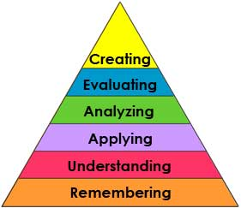
Curriculum Standard  Students use a variety of technology to answer questions. |  | Technology  Smartboard, IPADs |  |  |  |  |  |  | 21st Century Skills  Traditions in society
Materials  Smartboard, Smart Notebook,Calendar cards |  | Vocabulary (Literacy)  Holiday  Tradition  Memorial Day  Veteran
Lesson Procedures
Review(Links to Prior Knowledge, Anticipatory Set):

Review lesson on the life of an American soldier. There are many traditions we have in America. One is Memorial Day. Memorial Day is a day Americans remember veterans who died while serving as soldiers.
What the teacher will do:

Review smart lesson, show vocabulary cards, use visuals related to Memorial Day, ask comprehension questions.

What the teacher assistants will do: Take data and assist students in choice making
Guided/Independent Practice
Follow smart lesson, interact with lesson on smart board
Assessment/Check for Understanding
Students will answer comprehension questions: What is a tradition? What day do we celebrate Memorial Day? Why do Americans celebrate Memorial Day?
Students will say whether they liked the lesson or not.

Closure/Summary
Discuss/brainstorm other holidays and traditions America has (Fourth of July, President’s Day, New Years, etc)

Reflection  (after teaching the lesson) | Differentiation |  |  | Student Engagement |  | Data  Collection |  | Higher Level Question |  | Lesson Effectiveness
 | Low High  1 2 3 4 5 |  |  | Low High  1 2 3 4 5 |  | Low High  1 2 3 4 5 |  | Low High  1 2 3 4 5 |  | Low High  1 2 3 4 5
Comments | What would you do differently and what worked well?

