Teacher  Amber Askew/Tiffany White |  |  | Date  6/2/14  6/9/14 |  | Grade  9/10/11 |  | Content Area  Social Studies
Objective/Essential Question:  Who was Helen Keller? Why is she important?  - Physical Skills: Interact with smart board and classroom technology.  - Cognitive Skills: Answer comprehension questions.  - Social Skills (learning teams): Work in teams. Turn taking |  |  |  |  |  |  |  |  | Plan for Differentiation:  Using Bloom’s Revised Taxonomy  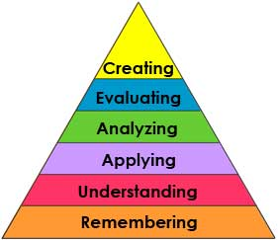
Curriculum Standard  Students will understand key ideas and details  Students will use multiple sources of information to utilize tools to understand historical facts. |  | Technology  Smartboard, IPADs |  |  |  |  |  |  | 21st Century Skills  Students will interact with the smart board and ACC devices
Materials  Smartboard, Smart Notebook,Vocabulary cards |  | Vocabulary (Literacy)  Blind  Deaf  Teacher  Water
Lesson Procedures
Review(Links to Prior Knowledge, Anticipatory Set):

Who was Helen Keller? Helen Keller was a woman who was blind and deaf. She was taught by Annie Sullivan and went on to advocate for human rights.
What the teacher will do:

Review smart lesson, show vocabulary cards, use visuals related to Helen Keller, ask comprehension questions.

What the teacher assistants will do: Take data and assist students in choice making
Guided/Independent Practice
Follow smart lesson, interact with lesson on smart board
Assessment/Check for Understanding
Students will answer comprehension questions: Who was Helen Keller? Who was Annie Sullivan? What does it mean to be blind/deaf?
Students will say whether they liked the lesson or not.

Closure/Summary
Students will watch videos about Helen Keller
Closure will be a recap of information for the day

Reflection  (after teaching the lesson) | Differentiation |  |  | Student Engagement |  | Data  Collection |  | Higher Level Question |  | Lesson Effectiveness
 | Low High  1 2 3 4 5 |  |  | Low High  1 2 3 4 5 |  | Low High  1 2 3 4 5 |  | Low High  1 2 3 4 5 |  | Low High  1 2 3 4 5
Comments | What would you do differently and what worked well?

