Teacher  Casey Campbell/Tiffany White |  |  | Date  2/24/14 |  | Grade  9/10/11 |  | Content Area  Social Studies
Objective/Essential Question:  Study a historical narrative.  Who are some African Americans that impacted history?  Who is George Washington Carver? What is his contribution to history?  - Physical Skills: Interact with smartboard and maps  - Cognitive Skills: Answer comprehension questions related to reading.  - Social Skills (learning teams): Turn taking, work with a partner |  |  |  |  |  |  |  |  | Plan for Differentiation:  Using Bloom’s Revised Taxonomy  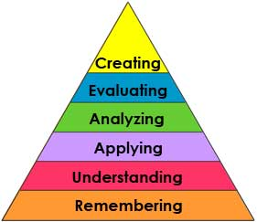
Curriculum Standard  Study a historical narrative. |  | Technology  Smart board  Videos |  |  |  |  |  |  | 21st Century Skills  How are our lives impacted by what George Washington Carver did in history?
Materials  Smart Board  Map  Computer  Picture board of African Americans throughout history. |  | Vocabulary (Literacy)  Legacy
Lesson Procedures
Review (Links to Prior Knowledge, Anticipatory Set):

February is Black History Month. Who are some influential African American’s throughout history? Students point to pictures on the chart.
What the teacher will do:

Read biographical info from smart notebook about George Washington Carver to the students. Ask comprehension questions throughout the reading. Explain unfamiliar or new vocabulary throughout the reading.

What the teacher assistants will do: Take data, assist students while answering comprehension questions.
Guided/Independent Practice
Students will identify famous African Americans throughout history.
Students will answer comprehension questions during reading in partner groups.
Assessment/Check for Understanding
Students will answer comprehension questions during reading in partner groups.
Students will say whether or not they liked the reading.

Closure/Summary
Students give their opinion of the reading.
Reflection  (after teaching the lesson) | Differentiation |  |  | Student Engagement |  | Data  Collection |  | Higher Level Question |  | Lesson Effectiveness
 | Low High  1 2 3 4 5 |  |  | Low High  1 2 3 4 5 |  | Low High  1 2 3 4 5 |  | Low High  1 2 3 4 5 |  | Low High  1 2 3 4 5
Comments | What would you do differently and what worked well?

