Teacher  Amber Askew/Tiffany White |  |  | Date  5/5/14 |  | Grade  9/10/11 |  | Content Area  Social Studies
Objective/Essential Question:  What is Cinco de Mayo?Why do we celebrate it?  - Physical Skills: Interact with smart board and classroom technology.  - Cognitive Skills: Answer comprehension questions.  - Social Skills (learning teams): Work in teams. Turn taking |  |  |  |  |  |  |  |  | Plan for Differentiation:  Using Bloom’s Revised Taxonomy  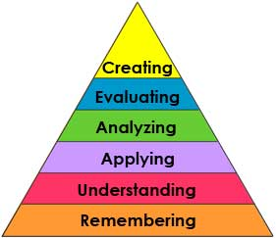
Curriculum Standard  Students use a variety of technology to answer questions |  | Technology  Smartboard, IPADs |  |  |  |  |  |  | 21st Century Skills  Traditions in society
Materials  Smartboard, Smart Notebook,Calendar cards |  | Vocabulary (Literacy)  Holiday  Tradition  Cinco de Mayo  Mexico
Lesson Procedures
Review(Links to Prior Knowledge, Anticipatory Set):

There are many traditions that we have as Americans. One is Cinco de Mayo. Although it was originally a Mexican holiday, we celebrate it in America because many people from Mexico have migrated or moved to America.

What the teacher will do:

Review smart lesson, show vocabulary cards, use visuals related to holiday, ask comprehension questions.

What the teacher assistants will do: Take data and assist students in choice making
Guided/Independent Practice
Follow smart lesson, interact with lesson on smart board
Assessment/Check for Understanding
Students will answer comprehension questions: What is a tradition? What day do we celebrate Cinco de Mayo? Why do Americans celebrate it?
Students will make posters to show what they have learned.
Students will say whether they liked the lesson or not.

Closure/Summary
Discuss/brainstorm other holidays and traditions America has (Fourth of July, President’s Day, New Years, etc.)
Students give their opinion of the reading.

Reflection  (after teaching the lesson) | Differentiation |  |  | Student Engagement |  | Data  Collection |  | Higher Level Question |  | Lesson Effectiveness
 | Low High  1 2 3 4 5 |  |  | Low High  1 2 3 4 5 |  | Low High  1 2 3 4 5 |  | Low High  1 2 3 4 5 |  | Low High  1 2 3 4 5
Comments | What would you do differently and what worked well?

