Teacher  Tiffany White |  |  | Date  4/21/14  4/28/14 |  | Grade  9/10/11 |  | Content Area  Social Studies
Objective/Essential Question:  Use technology to obtain historical data from a variety of resources.  - Physical Skills: Interact with smart board and classroom technology.  - Cognitive Skills: Answer comprehension questions.  - Social Skills (learning teams): Work in teams. Turn taking |  |  |  |  |  |  |  |  | Plan for Differentiation:  Using Bloom’s Revised Taxonomy  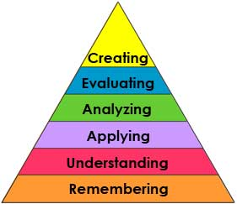
Curriculum Standard  Students use a variety of technology to obtain historical information. |  | Technology  Smartboard, IPADs |  |  |  |  |  |  | 21st Century Skills  What American inventions do we use today?
Materials  Smartboard, Smart Notebook, Unique Learning System |  | Vocabulary (Literacy)  Invention  Inventor
Lesson Procedures
Review (Links to Prior Knowledge, Anticipatory Set):

Discuss what an invention is, what an inventor does.
We use inventions every day. Many great inventions came out of America.
What the teacher will do:

Review smart lesson, show vocabulary cards, read American inventions chart and collect real items, provide each student with objects, ask comprehension questions.

What the teacher assistants will do: Take data and assist students in choice making
Guided/Independent Practice
Follow smart lesson, interact with lesson on smart board
Assessment/Check for Understanding
Students will answer comprehension questions: What is an invention? What does an inventor do?
Students will select and identify the real object.
Students will say whether they liked the lesson or not

Closure/Summary
Students interact with real objects that are American inventions. Students choose their favorite American invention.

Reflection  (after teaching the lesson) | Differentiation |  |  | Student Engagement |  | Data  Collection |  | Higher Level Question |  | Lesson Effectiveness
 | Low High  1 2 3 4 5 |  |  | Low High  1 2 3 4 5 |  | Low High  1 2 3 4 5 |  | Low High  1 2 3 4 5 |  | Low High  1 2 3 4 5
Comments | What would you do differently and what worked well?

